Write your research question in 1-2 sentences.
_____________________________________________________________________________________

_____________________________________________________________________________________

What words express the concepts in your research question? Brainstorm related words and concepts to those in your question.
Concept #1 AND Concept #2 AND Concept #3

___________________ ___________________ ___________________
OR
___________________ ___________________ ___________________

___________________ ___________________ ___________________

___________________ ___________________ ___________________

To search where concepts overlap, use AND To search synonyms/related concepts, use OR
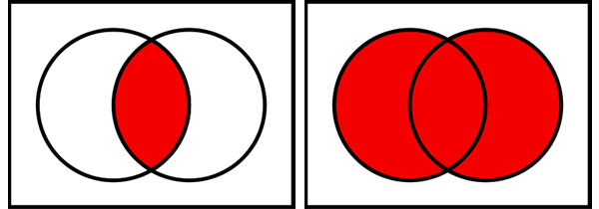

How many results did you get when searching your keywords? ______________________________________

Using the Filters provided to the left of your search results, limit your results to Peer Reviewed Articles. How many items are in your modified search results? _________________________________________________________________________________________

When reviewing your search results, did you identify additional terms that could be useful for searching? List those here:
_________________________________________________________________________________________

_________________________________________________________________________________________

_________________________________________________________________________________________

Write here the most effective search statement you used:
_________________________________________________________________________________________

_________________________________________________________________________________________

_________________________________________________________________________________________

